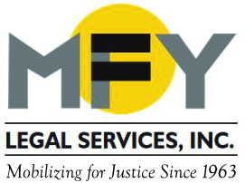

Update
February 2015

Recent Successes

MFY and Partners Win Class Status in Massive Debt Collection Case

Tens of thousands of New Yorkers who were never served legal papers in debt collection cases and had default judgments entered against them between 2006 and 2009 will have their day in court. In a suit brought on behalf of debtors by MFY Legal Services, the New Economy Project, and Emery Celli Brinkerhoff & Abady LLP, the U.S. Court of Appeals for the 2nd Circuit ruled on February 10, 2015 that the lower court was right to certify classes in cases alleging the widespread practice of “sewer service” in a scheme by a debt-buying company, a law firm and a process serving agency. Read the decision here.

MFY-ACLU Report: Lender Abuses and Feeble Enforcement Cause Minority Homeowners to Lose Homes
In a new report, Here We Go Again: Communities of Color, the Foreclosure Crisis, and Loan Servicing Failures, MFY Legal Services (MFY) and the American Civil Liberties Union (ACLU) show that New York State communities of color are unnecessarily bearing the brunt of loan servicers’ modification failure, with no effective regulatory response from the government. The report, the first to analyze narrative data from the Consumer Financial Protection Bureau, demonstrates that regulatory authorities have failed to enforce fair lending laws and have not examined their own data to see if communities of color are benefitting equally from government loan modification programs.

MFY in the News . . .

The New York Law Journal reports on the Second Circuit’s decision to uphold class certification in MFY’s massive debt collection lawsuit.

The Brooklyn Eagle reports on delays in an ongoing case to save the tenancies of elderly residents at the Prospect Park Residence in Brooklyn as the situation in the facility deteriorates.

The Wave, a local newspaper in Rockaway, reports on residents’ attempts – with MFY’s help – to appeal FEMA’s insistence that residents return money they had been granted after losing their housing and belongings during Superstorm Sandy.

