Update
July 2017

NYC Tenants Will Now Have Fighting Chance in Housing Court
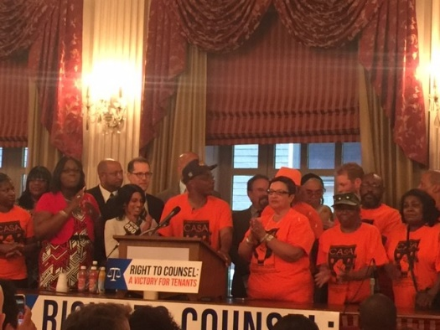
After years of advocacy by Mobilization for Justice and scores of other organizations, the City Council voted on July 20, 2017 to establish a universal access to counsel in housing court for tenants facing eviction. Increased city funding for legal assistance for tenants over the past two years has already had a profound impact. Evictions are down 24%, and the proportion of tenants represented went from a mere 1% prior to the increase to 27%. The new legislation, to be phased in over five years, will eventually make legal counsel available to 100% of low-income tenants who face eviction. The case stories below illustrate how important it is for tenants to have lawyers in housing court.

Mobilization for Justice Saves 30-Year Tenancy of Elderly Woman

New York City’s Senior Citizen Rent Increase Exemption (SCRIE) program helps protect low-income seniors against rent increases that eat away at their fixed incomes. Ms. K, now 84 and suffering from advanced dementia, was in danger of losing her home when her landlord brought a non-payment eviction proceeding claiming it was owed $31,000--the SCRIE portion of her rent for over 12 years. Because of her dementia, Ms. K had failed to renew her SCRIE benefit in 2005 and for more than a decade no one, including her landlord, noticed. Mobilization for Justice attorney Brenden Ross helped Ms. K secure a rental assistance grant from the city for $10,000, which the landlord accepted as full payment of arrears, and advocated with the city to re-freeze Ms. K’s rent at the 2005 amount. Without an attorney, Ms. K would surely have lost her home and ended up in a costly nursing home.

Willkie Extern Thwarts Landlord’s Phony Renovation Scheme

When two rent-stabilized West Village tenants refused to accede to their landlord’s demand to relocate so it could make building renovations, the landlord moved for a preliminary injunction against them in Supreme Court. Willkie Farr & Gallagher extern Samuel Kalar cross-moved to dismiss the lawsuit. He successfully argued that the landlord’s claims that floors were in imminent danger of collapsing were not supported by inspections or orders from the city agencies that have authority to issue a vacate order and that the landlord had offered a permanent relocation, not the temporary relocation it claimed, proving that the goal of the purported renovation was to remove the tenants.. Renovation and construction harassment are common tactics used by landlords to move rent-stabilized tenants out of their buildings.

MFY in the News . . .

The New York Times quoted Mobilization for Justice Supervising Attorney Elizabeth Lynch in an article on a new government report showing that HUD sold thousands of distressed mortgages to private equity firms and hedge funds without following proper rules for setting up the program.

WNYC ran a piece on how New York State has attempted to subvert the settlement allowing some 4,000 residents of adult homes with mental illness to move to supportive housing.

In reporting on three new appointees to the Southern District of New York, The New York Law Journal included mention of the pro bono work for Mobilization for Justice by Robert Lehrberger, an attorney at Patterson Belknap Webb & Tyler.

