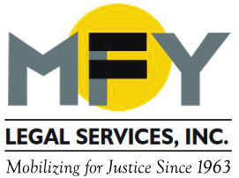

Update
June 2016

MFY Report Details Airbnb’s Disastrous Impact on NYC’s Housing Market

A report by MFY Legal Services and Housing Conservation Coordinators shows that Airbnb rentals are having a disastrous impact on NYC’s housing market and are significantly contributing to the decrease in affordable units, especially in Manhattan and Brooklyn. More than half of Airbnb’s listings are illegal under city housing law, and 30% of listings are controlled by illegal “commercial” hosts, in effect removing more than 8,000 apartments from the rental market at a time of a severe shortage of affordable units. Read report here.

Elderly Brooklyn Residents Win $3.35 Million Settlement

After a two-year battle, five residents of the Prospect Park Residence in Brooklyn who refused to leave when the new owner abruptly announced the facility’s closing in 2014, won a $3.35 million settlement and time to relocate to appropriate housing. They were represented by MFY Legal Services, The Legal Aid Society, and Fitzpatrick, Cella, Harper & Scinto. Legal claims remain against the NYS Department of Health, whose weak regulations allowed the operator to close the facility with essentially no notice to vulnerable elderly people.

Harassment by Construction: Crown Heights Tenants Fight Back

Represented by MFY Legal Services, tenants in a Crown Heights building filed suit against their landlord on June 7, 2016, demanding an end to almost two years of unbearable living conditions. Tenants say the landlord began a gut renovation in February 2015 without proper building permits. Tenants have lived through periods with no heat or water; walls have been removed and tenants are living with a rat infestation and black mold. The suit demands the restoration of illegally deregulated apartments back to rent stabilized status, restoration of services, and an end to the bullying and harassment of all tenants.

Simpson Thacher & Pillsbury Winthrop Honored at MFY Benefit

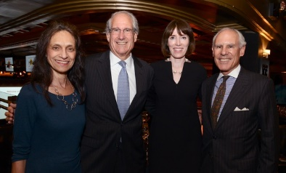
More than 450 people attended MFY’s annual Dinner-Theatre Benefit on June 15, which honored David Ichel and Simpson Thacher & Bartlett, and David Keyko and Pillsbury Winthrop Shaw Pittman. A video shown at the event highlighted Simpson’s pro bono work with MFY for children with mental illness and Pillsbury’s pro bono work on behalf of people with disabilities who need Access-a-Ride services.

MFY’s Brian Sullivan Honored by NYC Bar Association

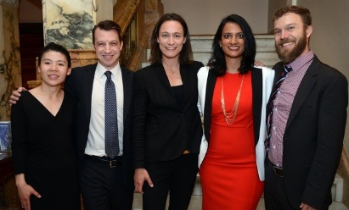
MFY Staff Attorney Brian Sullivan (far right) received the NYC Bar Association’s Legal Services Award for outstanding civil legal assistance to New York’s poor in a ceremony at the Bar Association on June 1. Sullivan is a senior member of MFY’s housing unit and focuses on helping SRO residents preserve their affordable housing. Among the other honorees are two former MFY staff attorneys, Donna Chiu and Runa Rajagopal.

MFY in the News . . .

MFY’s Airbnb report has generated significant media attention, with reports in the Daily News, NY Post, Guardian, AM-NY, CBS-TV, Gothamist, Skift, The Real Deal, and Patch.

MFY Supervising Attorney Marti Weithman comments on an Upper West Side SRO fined for offering short-term stays. And the New York Times ran a feature on a very different SRO in the same neighborhood.

The New York Times continues to cover the three-quarter house industry, most recently reporting on new fraud charges against Yury Baumblit for illegally evicting and defrauding tenants. MFY has represented many of Baumblit’s tenants and filed a class action lawsuit for deceptive practices against Baumblit’s companies with co-counsel Patterson Belknap Webb & Tyler.

