Update
August 2017

A Tale of Two Section 8 Tenants

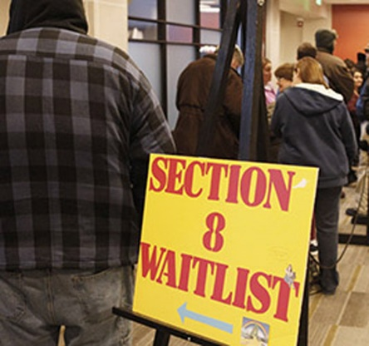
The federal Section 8 housing program enables millions of low-income individuals and families in the United States to afford to rent a private or public housing apartment. Tenants pay approximately 30% of their income to rent and Section 8 pays the rest. Losing a Section 8 voucher can mean a quick descent into homelessness. Two recent cases illustrate the difficulties faced by Section 8 tenants.

Mr. G, a 77-year-old Bronx resident, settled a holdover case in May 2016 by agreeing to obtain a Section 8 transfer voucher and to move to a new apartment. Due to his age and various impairments, Mr. G missed several deadlines to move, triggering a Marshal’s Notice of Eviction. MFJ attorney Alberto Gonzalez filed emergency motions (Orders to Show Cause - OSCs) after each eviction notice, buying Mr. G some more time, and he arranged for the city’s Adult Protective Services to help Mr. G find an apartment where he could use his Section 8 transfer voucher. When the judge refused to sign the last OSC, filed in July 2017, Gonzalez had one day to save Mr. G from going to a shelter. He filed a motion to reargue by OSC, which was heard by the judge who declined to sign the initial OSC. He convinced the judge that he would not be overstepping his authority by signing one more OSC, particularly since Mr. G had found an apartment and had a move-in date in September. The judge signed the order and a further stay of eviction, enabling Mr. G to move to his new home with dignity, with his Section 8 voucher secure.

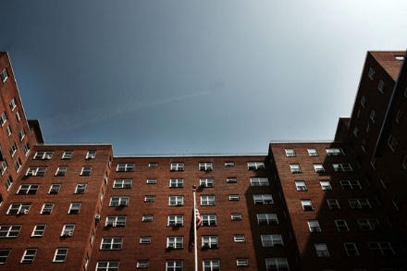
Ms. W received a termination notice from the NYC Housing Authority (NYCHA) stating that her Section 8 voucher was being terminated due to unreported income and unauthorized occupancy. It turned out that Ms. W’s former boyfriend used her address, and several others, to evade paying taxes, and that NYCHA actually knew about this but wanted to proceed with the termination of Ms. W’s voucher, or at the very least place her on probation. The client would not agree and MFJ housing paralegal Jeffrey Bohn negotiated more time to gather documentation to prove that Ms. W’s ex-boyfriend engaged in a fraudulent scheme, that he never lived with Ms. W and did not have her consent to use her address. NYCHA agreed to examine the documents to see if a settlement could be reached. NYCHA refused, and the client refused. Again, Bohn insisted that NYCHA simply withdraw the case and, after many months of waiting, NYCHA withdrew the case.

As a result of Bohn’s advocacy, Ms. W’s Section 8 voucher is secure, and she did not face the impossible task of trying to find an affordable apartment in an unaffordable city.

MFY in the News . . .

When MFJ Attorney Christopher Fasano was explaining to an NBC-TV reporter MFJ’s class action lawsuit against the U.S. Department of Housing & Urban Development (HUD) and Lone Star, a hedge fund that had been buying FHA mortgages and giving African-American homeowners in NYC predatory modifications, Fasano steered him to Mobilization for Justice’s next campaign on this front – to stop City pension funds from investing in Lone Star. NBC-TV investigative reporter Chris Glorioso ran with the information, exposing how both the City and State invest in a company what wreaks havoc on the lives of so many New Yorkers, and even got NYC Comptroller Scott Stringer to address the issue on camera.

MFJ attorney Matthew Main is quoted in this NY Daily News article exposing the difficulties faced by three-quarter house residents after the closing of the last clinic operated by Narco Freedom, whose operators were indicted in 2014 on Medicaid fraud and other charges. Of the 1,200 former Narco Freedom residents, 370 have moved into permanent housing. Others remain in limbo, unsure of where they are going to live.

