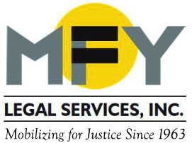

Update
April 2016

MFY Works with City Council to Rein In Abuses in Three-Quarter Houses

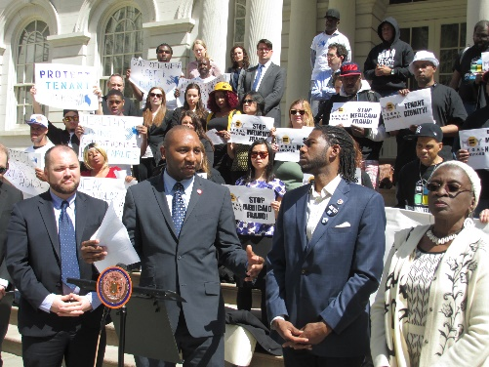
MFY Legal Services joined three-quarter house residents and City Council members on the steps of City Hall on April 20, 2016 to draw attention to and support for a package of bills that will require more public information on three-quarter houses, prevent landlords from requiring tenants to attend specific substance abuse programs, and improve tenants’ access to relocation services. The bills were sponsored by Council Members Donovan Richards, Jr., Ritchie Torres, Corey Johnson and Jumaane D. Williams.

Operators’ Arrest Exposes Medicaid Fraud in Three-Quarter House Industry

For years, three-quarter house tenants have reported being forced to attend specific substance abuse treatment programs by their landlord as a condition of living in a three-quarter house, even if they did not need treatment. Residents were required to bring back slips proving that they attended treatment. On Wednesday, April 13, 2016 Yury and Rimma Blaumblit, who run several three-quarter houses, were arrested on money laundering and Medicaid fraud charges arising from this pattern and practice and brought to the attention of criminal authorities by MFY. In 2010, MFY and Patterson Belknap Webb & Tyler LLP brought a class action lawsuit against three of Baumblit’s companies for deceptive practices, tenant harassment and violation of rent stabilization laws. If convicted, the Baumblits face up to 15 years in prison.

Zip Code Matters for Homeowners Trying to Fight Foreclosures
MFY Legal Services attorney Linda Jun is one of four primary authors of a report released this month by New Yorkers for Responsible Lending that lays bare the consequences for homeowners of inconsistent court procedures on foreclosure in New York State. Divergent Paths: The Need for More Uniform Standards and Practices in New York State’s Residential Foreclosure Conference Process shows how a homeowner’s zip code may make the difference between a successful loan modification and losing a home. Based on a statewide survey of how the courts in different areas handle settlement conferences, the report shows struggling New York homeowners have widely varying chances of saving their homes through this process depending on where they live.

MFY in the News . . .

NY1 interviewed MFY attorneys who are working to help Bronx tenants prevent evictions and address other housing problems at our satellite intake center at Bridge Builders.

MFY Staff Attorney Matthew Main is quoted in the New York Times’ coverage of Yury Baumblit’s arrest: “This action by the attorney general’s office sends the message that [tenants’] lives matter. The lives of poor people matter.”

MFY joined 14 national and local advocacy organizations in an amicus curiae brief urging the court to reverse a family court decision holding that a fetus is a “child” under New York’s Family Court Act. A unanimous panel of the Appellate Division, First Department vacated the ruling.

