Update
February 2016

Judge Orders Three-Quarter House to Stop Harassing Tenants

A Manhattan judge granted a preliminary injunction barring a three-quarter house landlord from harassing tenants. After three tenants represented by MFY Legal Services won eviction cases in Housing Court, the three-quarter house operator cut off heat, discarded tenants’ food, and required them to move to different rooms every 28 days in an attempt to evade unlawful eviction laws. This decision adds to a growing body of decisions supporting the right of three-quarter house residents to be considered tenants under New York housing law. Read decision here.

MFY Wins Settlement Approval in Two Class Action Lawsuits Demanding Unpaid Wages for Home Care Workers

MFY’s Workplace Justice Project settled two class action lawsuits on behalf of some 3,000 home health care workers who did not receive overtime and spread-of-hours pay, dating back to 2006. The plaintiffs, who provided personal care and assistance to the elderly and people with disabilities of the BNV Home Care Agency, Academy Care Givers, and First Care of New York, worked up to 70 or 80 hours a week or more. The settlements total $800,000 and $525,000. Abbey Spanier LLP served as co-counsel on the cases.

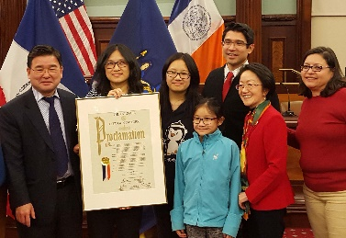
City Council Honors MFY Paralegal

City Council Member Margaret Chin presented a proclamation from the City Council to MFY Paralegal Fanny Chan in recognition of her tireless work over the past decade to help low-income residents of Chinatown with housing and public benefit issues. The presentation took place at a Lunar New Year celebration on February 29, 2016.

MFY in the News . . .

Supervising Attorney Elizabeth Lynch weighs in on consolidation of foreclosure cases in Kings County in a New York Law Journal article.

The New York Law Journal highlights the works of poverty justice fellows working at MFY and other organizations: Poverty Justice Fellows Fight for Tenants in Housing Court.

MFY has joined with other advocates in speaking out against illegal hotels: Local Officials Raise Alarm about Affordable Apartments being Converted into Hotels.

