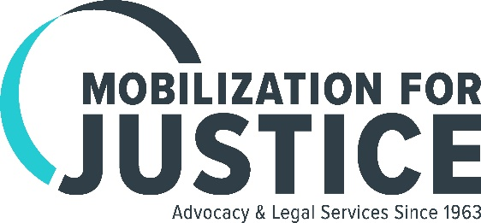
Update
June 2017

It’s Official – MFY Legal Services Is Now Mobilization for Justice!

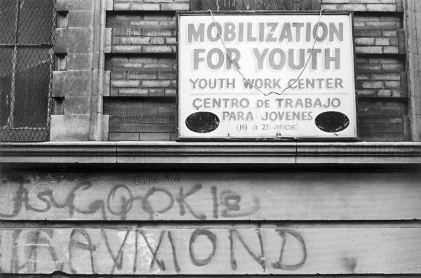
We opened our doors in 1963 as the legal unit of Mobilization for Youth, a large anti-poverty program supported by the Kennedy Administration and New York City to provide opportunities for residents of the Lower East Side that would help lift them out of poverty. In 1968 we became MFY Legal Services, Inc., an independent non-profit organization that worked closely with Mobilization for Youth. Over the years, MFY pioneered the idea of neighborhood-based legal services combined with policy advocacy and other activities to address the root causes of inequities facing our clients. Now, 54 years later, our new name, Mobilization for Justice, honors our past and connects us to our future.

Bedbug Battle Ends with Rent Abatement for Tenant

After years of struggling with a bedbug infestation from an adjacent apartment, Ms. M finally got relief. The situation, which began in 2009, had become so severe and the landlord’s efforts to correct the problem so ineffectual, that Ms. M eventually withheld rent. Instead of exterminating the source of the problem—the neighbor’s apartment—the landlord sued Ms. M for non-payment of rent. Ms. M reached out to Mobilization for Justice, and Staff Attorney Brenden Ross negotiated a settlement with the landlord shortly before the case was set to go to trial. Ms. M won a 50% rent abatement and the landlord set up three treatments of Ms. M’s and the neighbor’s apartment to finally get rid of the bedbugs.

Mobilization for Justice Prods MTA to Fix Access-A-Ride

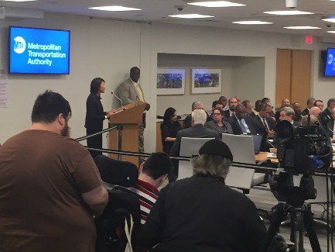
As part of a citywide coalition of disability advocates, Mobilization for Justice has been speaking out at meetings of the Metropolitan Transportation Authority (MTA), which has jurisdiction over Access-A-Ride, the city’s paratransit program for people with disabilities. Mobilization for Justice Staff Attorney Samantha Rauer, pictured at left, described long wait times and other problems that have plagued the system. In response to demands from users and advocates, the MTA agreed to expand e-hail services in a pilot program that will launch at the end of this year.

MFY in the News . . .

Some 350 guests packed The Edison Ballroom on June 14 for our annual Dinner-Theatre Benefit, which honored Cravath, Swaine & Moore LLP and celebrated our new name.

Mobilization for Justice Staff Attorney Jota Borgmann was featured in a WBAI Radio interview discussing the current situation of adult homes and New York State’s attempts to undercut the settlement in O’Toole v. Cuomo, which compelled the State to provide supported housing in the community for adult home residents who wished to move to a less restrictive setting.

This article in the New York Daily News exposes how New York State paid $700,000 to private attorneys to fight having to change its policies to protect elderly or disabled New Yorkers facing eviction. The State’s failure to protect elderly residents was brought to public attention when five residents, represented by Mobilization for Justice and The Legal Aid Society, refused to leave the Prospect Park Residence after a new landlord demanded they leave in 90 days.

The Bowery Boogie highlights an all-too-familiar problem in the East Village – landlord harassment of tenants and the loss of long-time retail establishments in favor of trendy coffee shops and bars.

