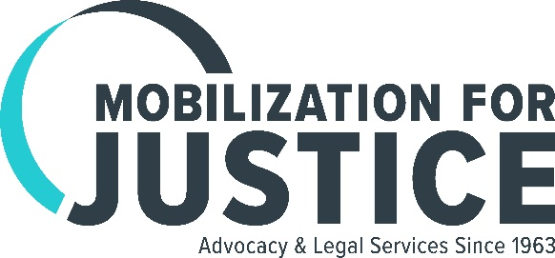
Information:
Dolores Schaefer, 212-417-3731
dschaefer@mfjlegal.org

Elise Brown, 212-417-3753
ebrown@mfjlegal.org

FOR IMMEDIATE RELEASE

MFY Legal Services Becomes Mobilization for Justice

Pioneering Legal Services Organization Rebrands
to Honor Its Past and Reflect Its Expanded Focus

NEW YORK, NY, July 5, 2017—MFY Legal Services (MFY), which began in 1963 as the legal arm of Mobilization for Youth, a large anti-poverty program on the Lower East Side of Manhattan, has changed its name to Mobilization for Justice.

MFY pioneered the concept of neighborhood-based legal assistance in low-income neighborhoods, beginning with four lawyers in a basement storefront on the Lower East Side. Within its first decade, it expanded to seven neighborhood offices, from Chinatown to Harlem. From its earliest years, it combined legal assistance to individuals with action to address the underlying inequities faced by the city’s most vulnerable residents.

Most notably in the late 1960s it challenged New York City’s policy of arbitrarily cutting people off welfare. The effort resulted in the 1970 Supreme Court decision in Goldberg v. Kelly, establishing an individual’s right to a fair hearing before benefits are terminated. That ruling ushered in what became known as the “due process revolution,” which has since impacted the lives of millions of low-income people throughout the country.

Today, Mobilization for Justice handles more than 12,000 individual cases throughout the five boroughs of New York City each year while initiating class action lawsuits and other impact litigation. Practice areas have grown from the organization’s traditional focus on housing and government benefits to include the largest legal project protecting the rights of people with mental illness who live in the community, along with units focusing on consumer rights, employment, bankruptcy, foreclosure, civil and disability rights, special education, immigration and kinship care.

In recent years the organization has won major class action lawsuits, including a $59 million settlement for people throughout New York State who were victims of abusive debt collection practices. A settlement in O’Toole v. Cuomo resulted in an agreement by New York State to develop thousands of units of supported housing for people with mental illness who have been warehoused in the city’s notorious adult homes.

“We are very proud that our new name ties us to our past and points to our future,” said Jeanette Zelhof, Mobilization for Justice’s Executive Director. “We have a dynamic staff that not only goes the extra mile for individual clients, but is actively involved in pushing for better policies on all levels of government, and each day looks for ways we can make our world better.”

# # #

