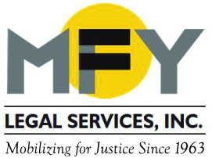

Update
December 2015

Settlement Prevents Eviction of Adult Home Residents
Who Use Wheelchairs

When four adult home residents who use wheelchairs were threatened with eviction, the discriminatory nature of New York State’s regulations on adult homes and the regulations’ conflict with the federal Fair Housing Act came into sharp focus. State regulations prohibit adult homes from having residents who are “chronically chairfast” and “unable to walk without assistance” even though people who use wheelchairs live successfully in similar settings. After a judge refused to issue a Temporary Restraining Order, the case went to mediation. The settlement calls for the home to adopt non-discrimination policies that make it clear that it does not prohibit or discourage people who use wheelchairs or have other physical disabilities from living at the home, to adopt a reasonable accommodation policy that specifically includes applying for a waiver from state regulations in similar cases, and to pay damages. This settlement sets an important precedent that will benefit dozens of people at the home in question and potentially thousands of people in adult homes throughout New York State.

Save the Date for “Shuffle Along” in June 2016

MFY’s 2016 Dinner-Theatre Benefit on June 15, 2016 will feature cocktails and dinner at The Edison Ballroom, followed by the new Broadway musical, “Shuffle Along.” The event will honor Pillsbury Winthrop Shaw Pittman LLP and MFY Board Member David Keyko and Simpson Thacher & Bartlett LLP and MFY Board Member David Ichel.

MFY in the News . . .

MFY Supervising Attorney Carolyn Coffey is quoted in two articles on debt collection: How Debt Collectors Ruin Lives in The Nation, and Lawyers engaging in debt collection may be regulated by a New York City ordinance, say courts in the ABA Journal.

MFY Staff Attorney Matthew Main is quoted in How New York’s Poorest Live, the latest exposé on three-quarter houses, in El Diario-La Prensa (translated by New York Voices).

