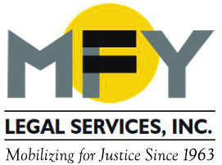
Update
February 2017

Coming Soon . . . A New Name for MFY! In the spring
MFY will become MOBILIZATION FOR JUSTICE.

City to Enact Legislation Mandating a Right to Counsel in Housing Court

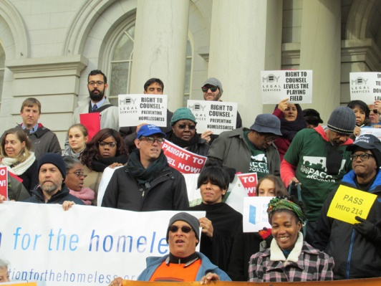
On February 12, 2017, Mayor Bill DeBlasio and City Council Speaker Melissa Mark-Viverito announced their commitment to passing legislation mandating universal access to legal representation for low-income tenants in housing court. MFY has been advocating for this right for years as part of the citywide Right to Council Coalition. The proposed legislation will provide free counsel to tenants whose incomes are within 200% of the Federal poverty rate and will level the playing field in housing court for thousands of tenants. A New York Times editorial urged the city to act and detailed the economic benefits of the plan.

Five New Bills Are Enacted to Protect Three-Quarter House Residents

After years of organizing and advocacy by the Three-Quarter House Tenant Organizing Project (TOP), MFY Legal Services, Neighbors Together, VOCAL-NY and other advocates in the Three-Quarter House Reform Coalition, the New York City Council passed a package of five bills to protect tenants’ rights and rein in abusive three-quarter house operators. Recently signed by the Mayor, the bills prohibit landlords from forcing tenants to attend medical treatment or interfere in any way with treatment, strengthen access to relocation services and to information on tenants’ rights. Read articles in the NY Times and the Queens Ledger.

MFY Launches New Program for Worker Safety and Health

Responding to the lack of legal assistance for low-income and immigrant workers injured on the job, MFY Legal Services is launching a new project on Workplace Safety and Health as part of its Workplace Justice Project. The project will provide advice, counsel and representation to workers who are injured on the job or who face unsafe or unhealthy conditions and who cannot get representation from the private bar. The project will offer assistance on Workers’ Compensation claims, medical leave and disability accommodations, disability discrimination, and reporting unsafe conditions. The project also provides training and is partnering with Mt. Sinai Selikoff Centers for Occupational Health.

MFY in the News . . .

MFY has redoubled its outreach efforts to immigrant communities in the wake of the Trump Administration’s executive orders on immigration. MFY Attorney Ernie Collette shares his expertise at a forum for immigrants sponsored by Univision, at a community forum in Washington Heights, and in a City Limits article on the safety of city services for immigrants. MFY is helping to staff an emergency hotline for immigrants, and is working with State Senator Jesse Hamilton to create a “sanctuary district” in Sunset Park.

MFY is representing tenants in several buildings who have been without heat or cooking gas for long periods of time. Here is an article about tenants MFY is representing in Crown Heights.

