Update
February 2018

Chelsea Tenants, Displaced by Fire, Fight Back with MFJ’s Help

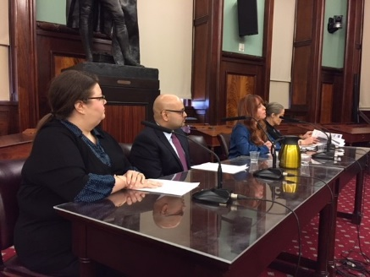
After a Christmas Day fire ripped through their Chelsea walk-up forcing tenants who had lived in the building for decades to move to temporary shelter, rather than make the necessary repairs as is required under law, the landlord sent termination notices purporting to end their leases on account of the fire, which is not a ground for termination. NBC New York covered the story, and State Senator Brad Hoylman reached out to MFJ for help. Liz Dunn, an attorney with Willkie Farr & Gallagher who is an extern at MFJ, is now working with the tenants to sue the landlord to make repairs so that the tenants can return home. MFJ also worked with the tenants pictured in the accompanying photo to prepare testimony they gave to the NYC City Council about the deleterious effects of tenant harassment. The tenants served with termination notices have lived in the building for 23 years, 45 years, and nearly 50 years, respectively.

MFJ Saves the Day for Taxi Driver after His Identity Was Stolen

Mr. A, a South Asian immigrant who supports his three children on a $30,000-a-year salary as a taxi driver, had subleased the use of a taxi medallion from a broker. The broker tricked Mr. A into signing a power of attorney, which was then used to steal Mr. A’s identity and fraudulently obtain and assign an $800,000 business loan in his name. Mr. A first discovered this when the assignee finance company contacted him to collect the alleged debt and then sued him for the defaulted loan. MFJ represented Mr. A, arguing in court papers that he was not responsible for the loan because he was the victim of fraud. Coupled with legal arguments and advocacy by MFJ Staff Attorney Ariana Lindermayer, the finance company dropped the case and agreed not to report the debt to the credit reporting agencies and to never contact him again about it.

MFJ Provides Holistic Services to Three-Quarter House Resident

Ms. Z, who lived in a three-quarter house in Far Rockaway, contacted MFJ for advice on dealing with harassment from her landlord. She later reached out to MFJ for help to appeal a denial of her application for Social Security Disability Insurance (SSD). MFJ Staff Attorney Traci Salami successfully represented Ms. Z at her appeal hearing, winning $22,000 in retroactive payments and SSD benefits of $1,431 per month. Based on the approval of her SSD application, MFJ Staff Attorney Peter Barker-Huelster was able to discharge $40,000 of her student loan debt. MFJ Staff Attorney Christopher Fasano is now working with Ms. Z to address some problems with her tax filings.

MFJ in the news . . .

Medicaid Fraud: For years, MFJ has worked to expose Medicaid fraud in the three-quarter house industry. On February 14, 2018, Yury and Rimma Baumblit pleaded guilty to two counts of grand larceny, admitting that they ran a kickback scheme with several Medicaid-funded treatment providers, thanks to MFJ’s work in uncovering the fraud. In December 2010, MFJ and Patterson Belknap Webb & Tyler sued the Baumblits and other providers for deceptive practices, pressuring tenants into signing away their rights, violating the rent stabilization code and laws, and unlawfully evicting tenants onto the street.

Airbnb: In an article in Bedford + Bowery, MFJ Supervising Attorney Justin LaMort comments on the recently published report from McGill University showing that Airbnb increases rent, quickens gentrification and earns most of its revenue in New York City from illegal rentals. “That there is no difference between the number of illegal listings in 2014 and 2017 is disappointing,” said La Mort. He said he hoped that Airbnb would take its responsibility to remove illegal postings from its platform seriously. “A small number of people renting out their couch, that’s not having an effect on the housing market. People with multiple homes pushing renters out, that affects a neighborhood.” Read article here.

