Update
May 2015

Recent Successes . . .

Times’ Exposé Draws Attention to Abusive Three-Quarter House Industry

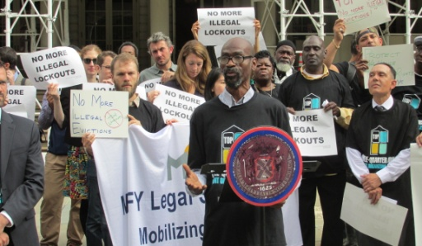
MFY’s work to defend residents of three-quarter houses and end abusive practices was recognized in a major exposé in the New York Times on May 31, 2015. Staff from MFY’s Three-Quarter House Project worked with the Times reporter over a period of many months and facilitated interviews with members of the Three-Quarter House Tenant Organizing Project (TOP), a group initiated by MFY and Neighbors Together, a community organization in Brooklyn. The article exposed how operators exploit tenants, get kickbacks from treatment providers, and force tenants to “relapse” and re-enter treatment in order to keep their room. The deBlasio administration announced the creation of a task force to address the problem.

MFY and Pillsbury Winthrop Represent People with Disabilities in Suit against NYC Transit

Five people with disabilities, represented by MFY and Pillsbury Winthrop Shaw Pittman LLP, filed a class action lawsuit in federal court against New York City Transit (NYCT) for the unconstitutional policies of Access-A-Ride, the city’s paratransit system for people with disabilities. The suit charges that NYCT fails to tell applicants and those recertifying eligibility why they are being denied services or receiving reduced services and that they have the right to appeal the denial in court. See Daily News article.

Superstorm Sandy Is Not Over for Hundreds of Families in Staten Island and Brooklyn

Superstorm Sandy may be a fading memory for most New Yorkers, but hundreds of homeowners in Staten Island and Brooklyn are still struggling with FEMA recoupments, contractor fraud, insurance disputes, mortgage problems and eligibility for the Build It Back program. MFY’s Disaster Response Law Project continues to advocate for these families, and over the past six months has generated more than $1,000,000 in savings for storm victims.

MFY in the News . . .

Huffington Post Interviews Three Quarter House Resident & Organizer
Recovering Addict Fears Crackdown on Three Quarter Housing Could Increase Homeless Problem
Bowery Tenants Protest Landlord They Say Is Pushing Them Out
Affordable Housing Units Might Be Lost after Air BnB-friendly Court Ruling
East Village Tenants Protest Landlord for Harassment: Court Action Imminent
State Abandoning Seniors Being Forced Out for Luxury Housing, Pols Say

