Update
May 2017

MFY will soon become
MOBILIZATION FOR JUSTICE.

MFY Sues State Health Dept. for Information on Recent Nursing Home Closures

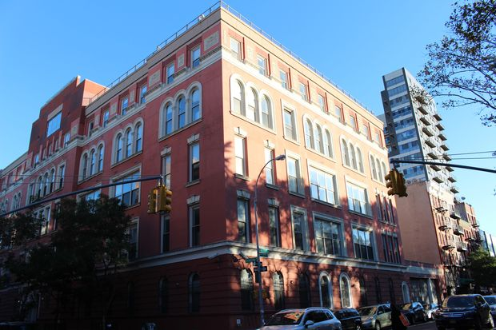
Alarmed that the New York State Department of Health (DOH) failed to protect residents of two nursing homes that were purchased, closed and then sold to luxury housing developers, MFY Legal Services, Inc. (MFY) filed suit in Supreme Court of New York County on May 9, 2017 challenging the DOH’s refusal to release documents related to its interactions with the Allure Group. The Allure Group purchased Rivington House, a nursing home for AIDS patients in Lower Manhattan, and CABS Nursing Home in Brooklyn, operated them briefly as for-profit facilities, then closed them to convert the properties to luxury residential buildings. “DOH’s review process for nursing home closures is supposed to protect vulnerable residents, but the Allure Group emptied its facilities quietly before flipping the properties to luxury developers,” said MFY staff attorney Daniel A. Ross. “We want to find out why the DOH provided so little oversight.” The suit was filed with pro bono assistance from Sidley Austin LLP.

MFY Thwarts Landlord’s Attempt to Empty an SRO Building

Although the Certificate of Occupancy for 94 Monroe Street in Brooklyn clearly states that the building in a Single Room Occupancy (SRO) dwelling, the landlord attempted to evict all ten tenants by sending them a notice stating that their leases had expired. Represented by MFY staff attorney Brian Sullivan, the tenants showed that the building is, in fact, rent-stabilized, and that they are tenants protected by the Rent Stabilization Code, not net lessees as the owner alleged. The ruling is significant in that illuminates the standards of proof required on a motion to dismiss, and the requirements for maintaining a holdover proceeding in a rent-regulated building.

MFY Has a New Home!

MFY is moving into its new home at 100 William Street, New York, NY 10038 on May 25. Although there are still boxes to unpack, our attorneys and paralegals will be ready to serve clients in our new location on Tuesday, May 30.

MFY in the News . . .

MFY’s lawsuit against the Department of Health seeking information on nursing home closures generated great interest from the press, with articles in the New York Daily News, New York Post, WNYC, DNAInfo, and TheLowdownNY.

MFY represents tenants at 80 York St. in the Crown Heights section of Brooklyn, profiled in this article in Patch: The Flipper’s Playbook: How NYC Slumlords Terrorize Tenants And Get Away With It

As the affordable housing crisis worsens, tenants seek to rent rooms instead of apartments. MFY staff attorney Brian Sullivan comments in this article in the New York Times.

