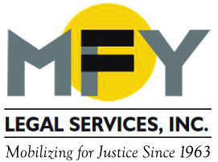

We Stand for Racial Justice
MFY Legal Services Endorses
The Joint Statement from NLADA and the Shriver Center
Members of the legal aid and public defender community were horrified and outraged by the killings of Alton Sterling and Philando Castile. Two more Black lives taken by those who ostensibly serve and protect. We must find a better path toward justice for our society and for people of color. A first step for our community is to state firmly that we stand in solidarity with the Black community and against the racial inequality that still plagues our nation.
We affirm what should be undeniable—Black Lives Matter. The recurring violence against Black people is but an extreme manifestation of our society’s persistent racism, which denies the Black community, and other communities of color, the right and opportunity to be safe and healthy, to work and live with dignity, and to flourish. Read entire statement here.
.

