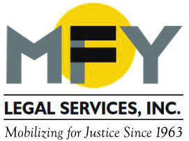

MFY and partners settle massive debt collection
class action lawsuit for $59 million

Over 300,000 victims will benefit

Over 190,000 default judgments to be vacated
Tens of thousands of low-income New Yorkers who were victims of abusive debt collectors won an unprecedented victory on November 12, 2015 when a settlement was reached, ending a six-year battle to achieve justice for low-income New Yorkers whose bank accounts were restrained or wages garnished after default judgments based on “sewer service” were entered against them.
“Thousands of low-income people across the state suffered severe financial consequences as a result of the callous and illegal actions of the three sets of defendants,” said MFY Supervising Attorney Carolyn Coffey, who co-counseled the case with Senior Staff Attorney Ariana Lindermeyer, and with the New Economy Project and Emery Celli Brinckerhoff & Abady. “We expect this settlement will have far-reaching consequences across the debt-collection chain and will help to put an end to predatory practices by debt buyers and the law firms and process serving companies that work with them.”

