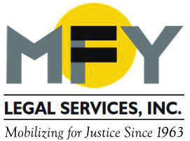

The Impact of the Presidential Election
In a dignified message to the nation on January 10, 2017, President Barack Obama urged the country to be vigilant about our democratic processes and to try to be hopeful in the face of enormous challenges ahead. MFY Legal Services was born of one of the first anti-poverty programs in the country, and remains committed to our mission to achieve social justice, prioritizing the needs of people who are low-income, disenfranchised or have disabilities. We stand with the Shriver Center in expressing our concerns about the high rate of poverty in this country and about the president-elect’s nominees whose records and statements evince values to which we do not subscribe. We will advocate more than ever to preserve and expand the social safety net and civil rights for our clients.

