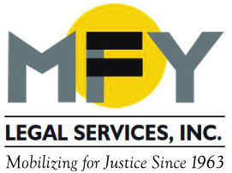
Update
March 2017

Coming Soon . . . A New Name for MFY! In the spring
MFY will become MOBILIZATION FOR JUSTICE.

Judge Blasts NYS for Undermining Adult Home Class Action Settlement

At a hearing on March 22, 2107, Judge Nicholas G. Garaufis criticized New York State agencies for using the state courts to try to undermine a federal class action settlement. Under that 2013 settlement the state agreed to provide 2,000 units of supportive housing—and more if needed—for adult home residents with mental illness who want to live more independently in supported housing in the community. But in response to litigation by the adult home industry filed in Albany County, the state agreed to a temporary restraining order enjoining its own regulations, which could render the federal settlement null and void. The state’s actions prompted the NYS Attorney General to request permission to withdraw as counsel for the Governor, New York State, and several state officials in two related civil rights cases. The Judge opened the hearing by summarizing over a decade of our litigation on behalf of adults with mental illness living in adult homes. WNYC reporter Cindy Rodriguez summarizes the hearing here.

Three-Quarter House Tenants Organize for Front Door Keys and a Mailbox

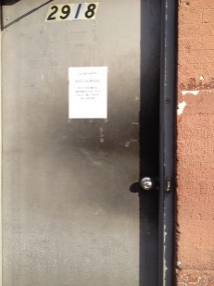
When a new owner bought a Harlem building serving as a three-quarter house from National Recovery Institute (after its CEO was indicted for Medicaid fraud last year), he had little interest in the men who were living there. The front door could only be opened when the “staff” was there – which was generally never – and the men had no keys and no mailboxes in which to receive mail. They were often forced to prop open the front door, leaving their belongings open to the street since there were also no locks on their individual rooms. Denise Romero, an MFY organizer, worked with the tenants, building relationships and encouraging them to work with residents in the Three-Quarter House Organizing Project (TOP) who have had similar experiences in the past. The men invited TOP members to a gathering in their kitchen – a simple but affirmative act by exploited men accustomed to living under strict control and subject to eviction at a moment’s notice. With support from TOP and represented by MFY, the tenants took the owner to housing court demanding front door keys and mailboxes. They won the case and, more importantly, their dignity.

MFY’s Neighborhood Clinic Helps Immigrant Worker End Harassment

At a neighborhood clinic in the South Bronx, MFY paralegal Elisa Medina met an immigrant construction worker who was being harassed by her supervisor, who made frequent comments about sex and assigned her to clean up saying she was the maid. The worker was fearful of speaking up, but Ms. Medina advised her that this conduct was unlawful, as is any retaliation for speaking up, and explained her rights regardless of immigration status. With Ms. Medina’s encouragement, the worker spoke to her supervisor’s boss, who kept his promise to end the harassment. MFY holds dozens of neighborhood-based clinics each month on housing, government benefits, consumer and employment matters, educating people about their rights, many of whom solve their own problems on their own with this knowledge.

MFY in the News . . .

Behavioral Health Executive examines the impact of recent City Council legislation providing greater protections for three-quarter house residents.

A new report, The Face of Airbnb, New York City, by Inside Airbnb, a member along with MFY of the Coalition against Illegal Hotels, documents the role that Airbnb plays in the gentrification of historically black and brown neighborhoods and the disproportionate benefit obtained by white hosts.

