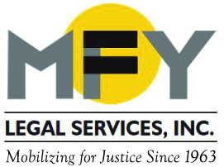

Update
May 2016

Class Action Compels NYC Transit to Change Unfair Access-a-Ride Policies
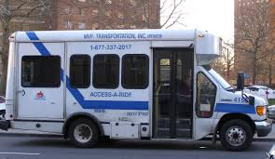
A class action lawsuit challenging unconstitutional practices of Access-A-Ride, New York City’s paratransit service for people with disabilities, received preliminary approval on May 19, 2016. Five plaintiffs with disabilities were represented by MFY Legal Services and Pillsbury Winthrop Shaw Pittman LLP. Once the settlement is finally approved, NYC Transit must provide specific information on why an applicant is denied, must provide the applicant’s file for free on request, and must continue services for those who previously had Access-A-Ride until their appeal is decided. It also requires NYC Transit to state that it does not discriminate against people with episodic disabilities.
Elderly Residents at Prospect Park Residence Win Settlement after Two-Year Battle

Patience and tenacity paid off for the five residents of the Prospect Park Residence in Brooklyn who refused to leave when the new owner abruptly announced the facility’s closing in 2014. Represented by MFY Legal Services, The Legal Aid Society, and Fitzpatrick, Cella, Harper & Scinto, the residents sued and reached a multimillion dollar settlement that will give them the resources and time to relocate to appropriate housing. Legal claims remain against the New York State Department of Health, whose weak regulations enable assisted living operators to close facilities with inadequate protections for vulnerable elderly people.

Lawsuit Charges Housing Discrimination against African-Americans and People with Rental Subsidies
MFY Legal Services is representing one of five plaintiffs in a federal fair housing lawsuit filed May 12, 2016 charging a Bronx landlord with discrimination against African Americans and people with rental subsidies. The suit details testing done over six months by the Fair Housing Justice Center that shows a pattern of discrimination by the owner of 15 buildings in the Bronx. The lawsuit alleges that the landlord’s refusal to rent to African Americans and people with rental subsidies constitutes discrimination based on race and source of income in violation of the NYC Human Rights Law and the federal Fair Housing Act. Emery Celli Brinkerhoff & Abady LLP is representing the other plaintiffs.

MFY in the News . . .

MFY Staff Attorney Andrew Darcy is quoted in the Norwood News’ article on residents’ struggle to preserve the Bedford Park area of the Bronx.

More coverage of the Prospect Park Residence settlement in The Brooklyn Paper, DNAinfo, Associated Press, and WPIX.

