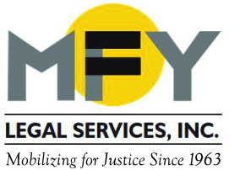

Update
October 2014

Recent Successes . . .

MFY’s Workplace Justice Project negotiated a $200,000 confidential settlement for two immigrant factory workers who suffered years of sexual and racial harassment and were then fired.

MFY’s Kinship Caregiver Law Project scored its first victory in an adoption subsidy fraud case on behalf of an adult sibling of three teens, ages 15, 16, 17. Although the three teens were no longer in the care of their adoptive mother, and the older sibling had secured legal guardianship, the adoptive mother was still receiving $2200/month for their care. Now the older sibling will receive $2,000 a month from the adoptive mother in child support.

Tenant Advocacy . . .
MFY urged the City Council to adopt Intro. 289, enabling HPD to provide housing applications in multiple languages.

A Client’s Perspective . . .

After MFY’s Mental Health Law Project saved the 20-year tenancy of a client at the last moment, the client wrote to his attorney: “. . . May I say that my gratitude will long remain as I reflect occasionally on how I came so close to losing the place I’ve called home for 20 years. . . As I share my experience with colleagues and friends … and express to them what I witnessed first hand at MFY, how you work at your profession with such a sense of immediacy and precision, together with a sense of solidary and compassion – everyone agrees that I have crossed paths with a truly unique individual.”

MFY in the News . . .

The October 29 New York Law Journal quoted MFY attorneys speaking out on the consequences for clients when no interpretation is available in court.

On October 27, Al Jazeera America reported on indictments against Narco Freedom, a substance abuse treatment agency that also runs notorious three-quarter houses. MFY has defended tenants against Narco Freedom in housing court.

On October 21, the Village Voice did an exposé on bad landlords, focusing on the legal action and community organizing of tenants in Chinatown, led by MFY.

The October 16 issue of AM New York featured an article on the growing number of eviction cases in housing court.

