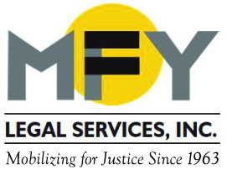

Update
August 2015

MFY and Patterson Belknap File Class Action Lawsuit on Behalf of People Trapped in Nursing Homes

Four people with disabilities filed a class action lawsuit in federal court against the New York State Department of Health (DOH), DOH Commissioner Howard Zucker, and Visiting Nurse Association Health Care, Inc. to challenge the illegal administration of a program that was designed, but failed, to facilitate the plaintiffs’ transition from nursing homes to their own homes. MFY and Patterson found that due to the poor and unconstitutional administration of the Nursing Home Transition and Diversion Medicaid Waiver Program, thousands of senior citizens and individuals with disabilities remain trapped in nursing homes instead of receiving the care that they need in their own homes.

MFY Expands Legal Services in the Bronx
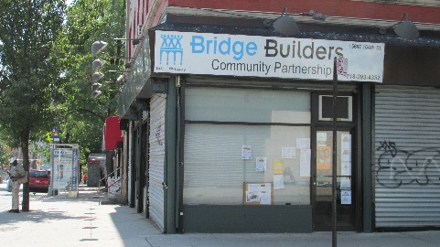
MFY will expand its work to a satellite office in the Bronx. Building on its kinship care work for Bronx families, MFY will now provide anti-eviction legal services to Bronx families with funding from the New York City HRA’s Homelessness Prevention Law Project. MFY will provide the full range of legal assistance needed to resolve a family’s housing problems, including representation in court, advocacy before administrative agencies, appellate work, and negotiations. MFY will conduct regular intake at Bridge Builders in the Highbridge section of the Bronx.

Three-Quarter House Operator Faces Criminal Charges

The New York Times reports that Yury Baumblit is facing criminal charges for illegally evicting tenants from three-quarter houses he operates. MFY has assisted hundreds of Baumblit’s tenants and has filed a class action lawsuit against Baumblit and others for widespread deceptive practices, harassment of tenants, violation of the rent stabilization code and laws, and unlawful evictions.

MFY in the News . . .

The New York Times quotes MFY Attorney Matthew Main: Mayor De Blasio Authorizes Emergency Measure to Aid Homeless People.

The New York Law Journal reports on Poverty Justice Solutions, a new program that allows MFY and other legal services providers to expand services to New Yorkers facing eviction in housing court.

