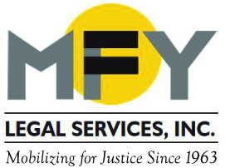

Update
December 2014

Recent Successes . . .

MFY attorney Chantal Hernandez scored a huge victory for homeowners facing foreclosure. Although the statute governing foreclosure provides that a bank must negotiate in good faith, the Second Department (which covers the counties with most of New York State’s foreclosures) had not interpreted what that means and what remedy the court can impose if banks fail to negotiate in good faith. The Appellate Division’s decision in MFY’s case holds that failure to follow federal government regulations is a failure to negotiate in good faith. That one sentence will alter the foreclosure landscape for years to come!

With MFY’s help, tenants in Chinatown have been challenging meritless eviction cases brought by a large landlord against elderly tenants in its buildings. After successfully winning dismissal of an eviction proceeding against two elderly residents (one of many brought over the years against a family that always paid its rent on time), MFY consumer attorney Evan Denerstein brought a complaint in the SDNY against the landlord’s attorney alleging violations of the Fair Debt Collection Practices Act, which prohibits attempts to collect debts that are not owed. The case settled on mutually agreeable terms.

Save the Date . . .

MFY’s annual Dinner-Theatre Benefit will be held on Wednesday,
June 10, 2015, with a cocktail reception and dinner at The Edison Ballroom, followed by a performance of An American in Paris at the Palace Theatre. The show premiered in Paris in December to rave reviews and will open in New York in March. With music by George Gershwin and spectacular choreography, it will be an evening to remember!

MFY in the News . . .

MFY has played a key leadership role in statewide advocacy efforts to rein in abusive debt collection practices. New rules announced in early December require debt collectors to produce a court judgment or actual loan document along with an accounting of all interest and fees included in the debt. MFY supervising attorney Carolyn Coffey is quoted in this Daily News article.

