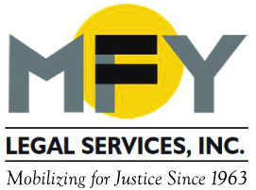

Update
July 2016

MFY Prevents Mass Eviction of Three-Quarter House Residents

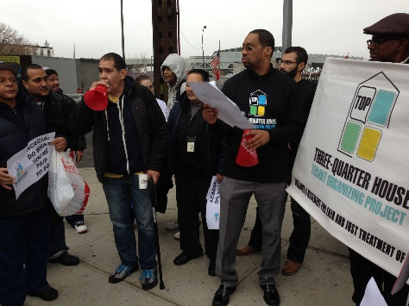
After the executives of Narco Freedom, which operated 18 three-quarter houses throughout the city, were indicted for Medicaid fraud and grand larceny, the state contracted with two nonprofit housing providers, Acacia Network and Samaritan Village, to operate the homes. Under the new operators, conditions in the homes quickly went from bad to worse and residents were evicted without notice or due process for minor violations of house rules, all with the blessing of the state Office of Alcoholism and Substance Abuse Services (OASAS). Evictions continued even after a Housing Court judge rejected OASAS’ argument that the tenants were exempt from tenant protection laws. Then, the providers told residents that the buildings would close by June 30 and everyone would be locked out unless they agreed to be transferred to notorious cluster-site shelters.

In late June MFY sued OASAS and the two providers for abuses and illegal evictions. After weeks of motion practice, MFY negotiated agreements that Samaritan and Acacia would not evict anyone without court process pending the outcome of the litigation. As a result, four hundred people are not facing homelessness.

MFY Report Spurs Three Senators to Urge FTC to Investigate Short-Term Rental Industry

MFY’s recent report on Airbnb rentals in New York City spurred three U.S. senators – Brian Schatz, Elizabeth Warren and Diane Feinstein – to urge the Federal Trade Commission to study and quantify the degree to which the rapidly expanding short-term lodging rental market affects the affordable housing market. Their July 13, 2016 letter states: “. . . we are concerned that short-term rentals may be exacerbating housing shortages and driving up the cost of housing in our communities. We have also read troubling reports of racial discrimination on some short-term rental platforms. Furthermore, we are concerned that communities and consumers may be put at risk through violations of sensible health, safety, and zoning regulations under state and local law.”

NYU Law Review: The Theft of Affordable Housing

MFY Supervising Attorney Justin La Mort explores how rent-stabilized apartments are disappearing as a result of fraudulent individual apartment improvements in the current issue of the NYU Review of Law & Social Change. The article shows how these phony improvements are exacerbating the city's affordable housing crisis and recommends several legal and policy changes to prevent the further theft of affordable apartments.

MFY in the News . . .

MFY’s Airbnb report continues to generate discussion near and far. Here are articles from the UK’s Independent and from Skift.

