Update
November 2017

WNYC Feature: MFJ Gives Tenants Their Day in Court

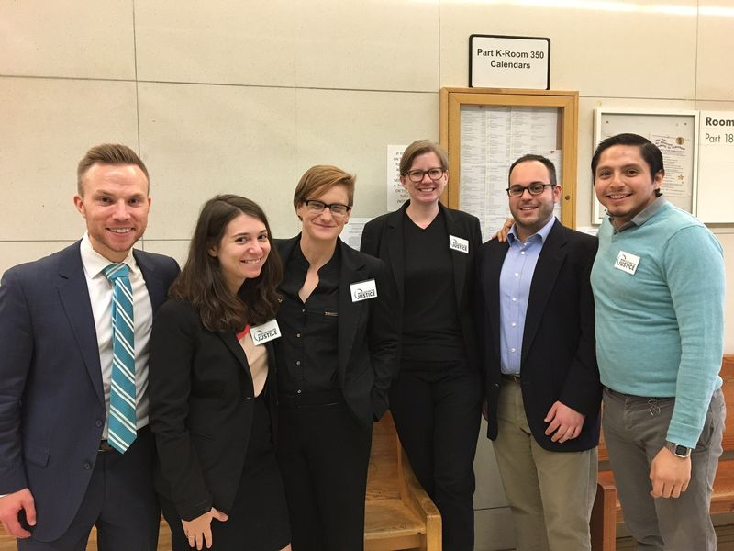
WNYC reporter Beth Fertig spent time in Bronx Housing Court with Mobilization for Justice attorneys and paralegals (pictured at left) examining how the city’s program providing universal access to counsel in housing court is working. MFJ attorneys are in the courthouse every Friday offering free legal assistance to low-income tenants who qualify. Over the past three years, representation for tenants facing eviction in NYC has increased from one percent to 27 percent. Supervising Attorney Andrew Darcy said the program is working: “Having some time to investigate these serious allegations and people losing their homes is not clogging up the wheels of justice or preventing anyone from getting something that they’re legally entitled to … it’s simply about giving tenants their day in court.” Read or listen to WNYC’s report here.
MFJ Defends Tenants Waging a Rent Strike after Three Heatless Winters

Mobilization for Justice is representing a group of Crown Heights tenants who are waging a rent strike after three winters without heat. As this report from News 12 Brooklyn shows, the landlord has engaged in serious harassment in an effort to force out rent-stabilized tenants. MFJ Attorney Brian Sullivan said, “They’ve illegally removed five of the eight units from rent stabilization and they’re charging the tenants way more than they legally should be able to.” MFJ has taken the landlord to court to return the five units to rent stabilized status and to restore heat and repair conditions in the other three rent-stabilized units.

MFJ Urges NYS Legislature to Improve Nursing Home Care and Safety

In testimony before the NYS Assembly Committee on Health, MFJ Attorney Daniel A. Ross offered a blueprint for improving the quality of care and patient safety in nursing homes and drew attention to the state Department of Health’s (DOH) lax enforcement of regulations protecting residents. Ross urged legislators to enact a staffing ratio bill to ensure high quality care; strengthen government oversight by increasing DOH’s funding for inspection and surveillance; protect residents facing involuntary discharge from nursing homes; ban overly restrictive day pass policies and ensure residents’ right to community integration; increase funding for the long-term ombudsman program and legal services; and require better investigation into the character and competence of operators.

