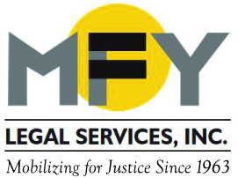

Update
September 2015

MFY Advances Citywide Advocacy Effort to End Construction-Related Harassment of Tenants and to Reform Buildings Department

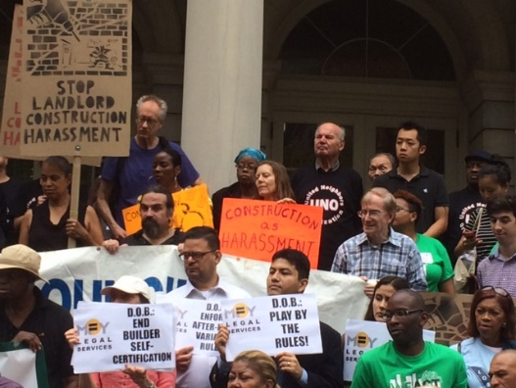
As part of the citywide Stand for Tenant Safety Coalition, MFY worked with housing and tenant organizations throughout the city to press the City Council to introduce a package of 12 bills to address negligent response time from the Department of Buildings (DOB), insufficient services from DOB, safety and health hazards, and landlords’ use of construction to force displacement and buyouts. As gentrification proceeds at breakneck pace in many communities, MFY is assisting scores of tenants whose lives have been upended by illegal construction and coerced by landlords to accept meager buyouts.

Three-Quarter House Residents to Get New Provider

MFY organizer Paulette Soltani’s comments on a judge’s decision to transition Narco Freedom residents to two new providers were featured in a recent CBS News report on the massive fraud case that landed Narco Freedom’s operators in jail and left hundreds of residents in housing limbo. Soltani said that the decision is “a promising plan only if it’s moving toward finding permanent housing for residents.”

Abused and Threatened, an Immigrant Worker Gets Justice

An immigrant worker from Chile came to MFY for help after suffering years of severe sexual harassment at work, including repeated rape. Her employer threatened to call immigration and ultimately fired her when she refused to submit to his sexual assaults. MFY worked closely with the client to help her tell her story first to the Equal Employment Opportunity Commission (EEOC) and then to the State Division of Human Rights (DHR). After a two-year effort, the EEOC issued the worker a U-Visa certification for crime victims, which will facilitate her application for a permanent U-Visa. Ultimately, HCR found probable cause for her claim of discrimination, a finding that prompted a significant monetary settlement. The worker is now on the road to gaining documented immigration status.

MFY in the News . . .
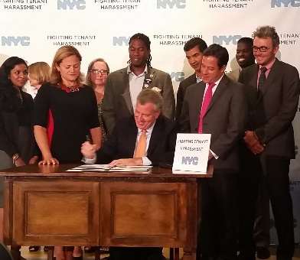
The Epoch Times quotes MFY Attorney Ariana Marmora on new laws to protect tenants from landlord harassment, and MFY Supervising Attorney Scott Stamper (standing far right in the accompanying photo) is quoted in the city’s press release on these new anti-harassment laws.

The New York Times quotes MFY Attorney Peter Barker-Huelster on the problems associated with loans from on-line bankers in Pitfalls for the Unwary Borrower Out on the Frontiers of Banking.
MFY Attorney Nahid Sorooshyari discusses MFY’s lawsuit on nursing homes with City and State: Advocates Say State Is Failing Nursing Home Residents.

MFY organizer Paula Soltani and three-quarter residents active in the Three-Quarter House Tenant Organizing Project (TOP) camped out overnight at City Hall to draw attention to the need for affordable housing for low-income people. Soltani spoke to Telemundo 47: Protestan Frente a Alcaldia de NYC.

