Update
September 2017

African-American Woman Wins Fair Housing Case Settlement Based on Race and Source of Income Discrimination

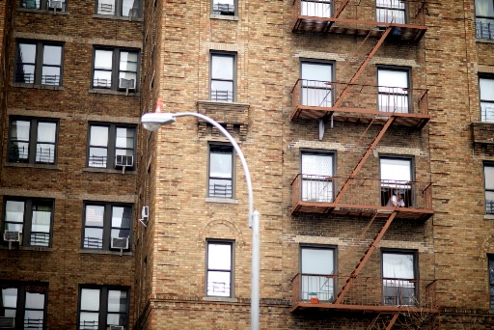
When Sandra, who was living in a shelter, received a voucher from New York City’s Living in Communities (LINC) rental assistance program, she looked forward to having a real home again. But like many other homeless families, she found landlords were not willing to accept her LINC voucher. The Fair Housing Justice Center (FHJC) conducted testing and found that Kosova Properties, which manages 19 buildings with more than 350 units in the Bronx and Manhattan, was discriminating against potential tenants based on race and source of income.
Sandra, represented by Mobilization for Justice, and three African-American testers and the FHJC, represented by Emery Celli Brinckerhoff & Abady LLP, filed suit in federal court, alleging race and source of income discrimination, including that the landlord’s refusal to accept LINC vouchers has a disparate impact based on race. The case, filed in May 2016, settled on the eve of trial. Under the four-year settlement agreement, the landlord agrees not to discriminate; to adopt a fair housing policy; undergo fair housing training; allow tenants who live in the one building where the defendants allegedly steered African-American tenants to transfer to available units in other buildings the defendants own; and hire a third-party employee who will handle rental inquiries at all of the larger rental buildings operated by the defendants. The settlement also includes a $620,000 monetary recovery.
MFJ Staff Attorney Shanila Ali, who handled the case, said: “No family should have to languish in the shelter system because of discrimination based on race or source of income. This settlement will send a strong message to landlords that fair housing is not a choice, it’s the law.”

Victory for Tenants: City Enacts Stand for Tenant Safety Bills

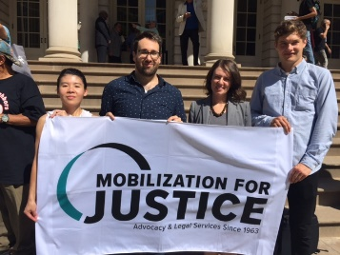
After years of advocacy by Mobilization for Justice and scores of legal services providers, tenant groups, and community organizations, the City Council passed and the Mayor signed into law 11 bills that strengthen the ability of the NYC Department of Buildings (DOB) to protect tenants from construction harassment, improper vacate orders, and dangerous conditions. Over the past several years, members of the Stand for Tenant Safety Coalition have raised the alarm about increasing incidence of illegal construction aimed at driving tenants from their apartments. The legislation requires the DOB to respond immediately to construction harassment complaints, increases penalties for offending landlords, and strengthens enforcement measures.

MFJ in the News . . .

MFJ Blasts Forced Arbitration Clauses in Daily News Op-Ed: MFY Staff Attorney Ali Naini’s Op-Ed in the New York Daily News exposes the dangers consumers face when credit services, banks and other financial institutions include in their products forced arbitration clauses that prohibit consumers from participating in class action lawsuits to address egregious behavior, such as the recent hacking of Equifax’s database of consumers’ personal information, and Wells Fargo’s creation of fake accounts for millions of Americans. Although the Consumer Financial Protection Bureau issued regulations in July preventing banks and other companies from requiring mandatory arbitration and class-action waivers in their agreements, the House of Representatives voted to kill the regulation, and the Senate is now set to take up the matter.
Immigrant Youth and Food Security: MFJ Staff Attorney Ernie Collette exposes the challenges faced by unaccompanied immigrant youth in securing government assistance for food benefits in this article in the Georgetown Immigration Law Journal. While many of the thousands of young people arriving in the New York area seek and qualify for immigration relief through asylum, protection as a victim of human trafficking, or aid through Special Immigrant Juvenile Status, their access to food stamps and other government assistance depends on the type of immigration relief they secure and what step their application is in.

Abandoned Tenants Rally to Demand Housing Help: The Queens Times Ledger reported on a rally on August 31 by three-quarter house tenants to fight the threat of homelessness after the NYS Attorney General charged directors of Interline with stealing over $2.3 million in a Medicaid kickback scheme. Tenants, whose housing is now in limbo, rallied to ask the City to provide Special Exit and Prevention Supplement (SEPS) vouchers to help them secure permanent housing. Like other substance abuse treatment programs that have been indicted on Medicaid fraud, Interline made participation in their treatment program a condition of housing, whether or not the individual needed treatment, provided substandard and overcrowded housing, and imposed restrictive house rules.

